Dr. Hamid Sarfraz
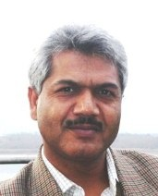

Programme Coordinator

IUCN Pakistan
I hold MPhil degree in Sociology from the University of Balochistan while my master’s degree was also in Sociology from University of the Punjab. I have attended extensive courses on management at the Lahore University of Management Sciences. During the last 20 years, I have been contributing to sustainable development through programmes’ coordination, project management, writing and teaching. Of these, more than 13 years have been with IUCN, International Union for Conservation of Nature where currently I am responsible to ensure a coherent and robust programme of the Union in Pakistan as its Programme Coordinator. Before joining IUCN, I have been teaching Social Psychology, Sociology of Education, Sociology of Population and Research Methodology to postgraduate students at the University of Balochistan for about seven years. I have written number of research articles, monographs and have compiled/edited a number of documents which are available at http://hsarfraz.webs.com/.

Nonprofit; Environmental Services industry
December 1998 – Present (12 years 11 months)
Specialization: M.Phil Sociology
Programme Coordinator
IUCN Pakistan
House 21, Street 88, G-6/3, Islamabad, Pakistan
Phone: +92 (51) 2271027
Fax: +92 (51) 2271017
Cell: +92 (345) 2004111
E-mail: hamid.sarfraz@iucn.org, hsarfraz@gmail.com

